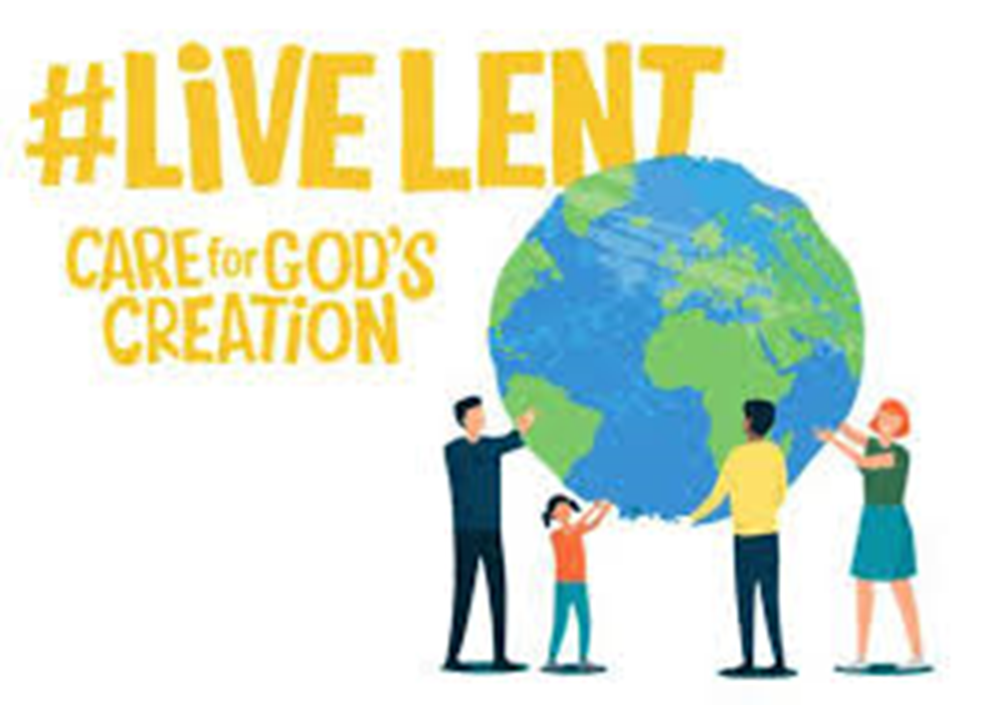

Care for God’s Creation – an Eco Lent Course inspired by
Ruth Valerio’s book, ‘Saying Yes to Life’

A course in five sessions
This Lent, we hope to engage in God’s plea for us to “Care for Creation”. It is an opportunity for us to rebuild our relationship with our planet, and in turn, with God who is Lord of everything. During this time, we hope you might engage in prayer, learn more about the remarkable world we have been given, and build habits that will last beyond the season to protect and honour the earth.

At this time of year, we are all called to listen and respond to God’s calling on each one of us in humility and repentance, so that Christ’s death and resurrection at the end of Lent can bring the renewal, response and reconciliation that we so long for.

Over the next five weeks we will be looking at reflections and suggestions which will provide us with an opportunity to come together to meet with God and rejoice in the beauty of His creation.

Each session will be approximately one and a half hours long. We ask that during this course we respect and actively listen to the viewpoints of those taking part, without making them feel pressured or undermined. We also ask that nothing said inside the group is repeated outside. Though everyone is free to speak, please be mindful of those who may not wish to share their thoughts.

Most important of all, I hope you will all enjoy a time of learning, fellowship and fun as we study the Word of God together.

Contents

Week 1 – Thursday 23rd February - Light and Energy
Session 1 – Let there be light

Week 2 – Thursday 9th March - Water
Session 2 – A Sacred Gift

Week 3 –Thursday 16th March - Land and plants
Session 3 – God’s good earth

Week 4 – Thursday 23rd March - Stars and Seasons
Session 3 – Night and Day

Week 5 – Thursday 30th March – All Living Beings
Session 5 – All Creatures Great and Small

Week 1 – Light and energy

Introduction and welcome

Open in prayer

Session 1 – Let there be light

The first chapter of Genesis has much to say about the created order and the place of human beings within it. But first and foremost, it conveys fundamental truths about God. It tells us that God existed before creation
that God alone made everything, and that God is good. On this first day, God speaks, and light – without which nothing has life – is created. Genesis 1 invites us to hear God’s voice and to see God’s goodness revealed in creation every day.

Read: Genesis 1:1-6 (NRSV)

In the beginning when God created the heavens and the earth, ² the earth was a formless void and darkness covered the face of the deep, while a wind from God swept over the face of the waters. ³ Then God said, “Let there be light”; and there was light. ⁴ And God saw that the light was good; and God separated the light from the darkness. ⁵ God called the light Day, and the darkness he called Night. And there was evening and there was morning, the first day.

Question: As you notice light around you today – light from the sun, a lightbulb or a candle – become aware of God’s presence in the world.
What does God say to you?

Discuss as a group

Light of the World
Jesus describes himself in John’s Gospel as “the light of the world” (8:12) In Matthews 5 he encourages his followers to see themselves in a similar way. The good news of God’s kingdom we have heard is news to be shared, not kept secret or hidden.

Read: Matthew 5: 14-16 (NRSV)
“You are the light of the world. A city built on a hill cannot be hid. No one after lighting a lamp puts it under the bushel basket, but on the lampstand, and it gives light to all in the house. In the same way, let your light shine before others, so that they may see your good works and give glory to your Father in heaven.”

As Christians, we are called to be God’s representatives on earth, to be His hands, feet, eyes, ears and heart.

Question: In the above reading from Matthew’s gospel, Jesus says, “You are the light of the world. A city built on a hill cannot be hid.” But are we doing enough to ‘let our light shine’ or do we hide it? And why?

Discuss in small groups

Light is a powerful symbol of God’s presence in the Bible, providing guidance in the darkness and showing his people the way. In Exodus 13, as the Israelites flee captivity in Egypt, God goes before them in a pillar of fire.

Read: Psalm 119: 105
“Your word is a lamp to my feet and a light to my path”.

God’s word illuminates our path, providing us with guidance on how we might walk in God’s light.

Question: We all need light – but we also need to reduce our carbon emissions. Switching to low energy LED bulbs is a small adjustment that could make a big difference. Discuss other ways that could actively make a difference as individuals and as a Church?

Discuss

Meditation/Reflection
During Lent we are encouraged to face the reality that there are many dark places in our lives and in our world. We need God’s light to open our eyes to the world’s needs, to bring hope into the darkness. Whatever challenge we face, it is important we remember, in the words of Archbishop Desmond Tutu, that “Good is stronger than evil; love is stronger than hate; light is stronger than darkness; life is stronger than death. Victory is ours, through him who loves us.”

Silence or music

Closing Prayer

We say the Grace together
Week 2 – Water
Introduction and welcome

Open in prayer

Session 2 – A Sacred Gift

This week we’ll be reflecting on water’s central place in both life and faith. We’ll explore how we can better use, conserve and share this sacred gift of God, strengthened and encouraged by our faith in Jesus who offers “living water”.

Read: Genesis 1:6-8 (NRSV)

⁶ And God said, “Let there be a dome in the midst of the waters, and let it separate the waters from the waters.” ⁷ So God made the dome and separated the waters that were under the dome from the waters that were above the dome. And it was so. ⁸ God called the dome Sky. And there was evening and there was morning, the second day.

The demand for water around the world is expected to rise by up to 50% by 2050. By conserving water, we acknowledge that water is sacred – a gift from God. Doing this will not only help us survive, but protect our landscapes and wildlife

Question: As you notice water today – when you drink, or fill up the kettle or the dishwasher, wash yourself, the dishes, water the plants or wash your clothes – are you aware of God’s precious gift to the world.
Or do you take it for granted? Think of ways we can help to conserve or recycle water.

Discuss as a group

Living Water

In John’s Gospel, Jesus refers to himself as “living water” - water that brings us blessing and refreshment right to the core of our being.

Read: John 4: 7-15 (NRSV)
⁷ A Samaritan woman came to draw water, and Jesus said to her, “Give me a drink.” ⁸ (His disciples had gone to the city to buy food.) ⁹ The Samaritan woman said to him, “How is it that you, a Jew, ask a drink of me, a woman of Samaria?” (Jews do not share things in common with Samaritans.) ¹⁰ Jesus answered her, “If you knew the gift of God, and who it is that is saying to you, ‘Give me a drink,’ you would have asked him, and he would have given you living water.” ¹¹ The woman said to him, “Sir, you have no bucket, and the well is deep. Where do you get that living water? ¹² Are you greater than our ancestor Jacob, who gave us the well, and with his sons and his flocks drank from it?” ¹³ Jesus said to her, “Everyone who drinks of this water will be thirsty again, ¹⁴ but those who drink of the water that I will give them will never be thirsty. The water that I will give will become in them a spring of water gushing up to eternal life.” ¹⁵ The woman said to him, “Sir, give me this water, so that I may never be thirsty or have to keep coming here to draw water.”
In this reading a woman goes to fetch water at a well, as was the custom of the day. We all need water to live, yet in some areas of the world drinking water can make you seriously ill or can even kill you. Did you know that 650 million people live without safe water and 2.3 billion people, one in three, don't have access to a toilet?

Question: What could we be doing as individuals and as a Church to help provide clean water and sanitation in areas of need?

Discuss in small groups

Read: Exodus 15: 22-27
²² Then Moses ordered Israel to set out from the Red Sea, and they went into the wilderness of Shur. They went three days in the wilderness and found no water. ²³ When they came to Marah, they could not drink the water of Marah because it was bitter. That is why it was called Marah. ²⁴ And the people complained against Moses, saying, “What shall we drink?” ²⁵ He cried out to the Lord; and the Lord showed him a piece of wood; he threw it into the water, and the water became sweet.
There the Lord made for them a statute and an ordinance and there he put them to the test. ²⁶ He said, “If you will listen carefully to the voice of the Lord your God, and do what is right in his sight, and give heed to his commandments and keep all his statutes, I will not bring upon you any of the diseases that I brought upon the Egyptians; for I am the Lord who heals you.”
²⁷ Then they came to Elim, where there were twelve springs of water and seventy palm trees; and they camped there by the water.

Freshwater ecosystems are in trouble. Since 1970, there has been an 83% decline in UK freshwater species of fish. Pollution kills life in our rivers and lakes and harms plants and animals – including humans. This is what sin looks like. Our environment destroyed. The lives of the most vulnerable inhabitants of our world endangered. Reversing pollution – so that the waters can be fresh again and sustain life – requires repentance; by governments, businesses, and by us too.

Question: Look in your kitchen and bathroom – is there one thing from each you could switch to a product that does not contain harmful chemicals? Discuss ways we could actively make a difference as individuals and as a Church, including using home remedies?

Discuss

Meditation/Reflection

Water is constantly moving around the Earth from land and sea to air, and then from the clouds back to the Earth as rain. God created and continues to create this cycle of water, which is an amazing feature of our world. Although fresh water covers less than 1% of the earth’s surface, we depend on it for our survival. It also provides the habitat for 10% of the world’s known species.

So, let us pause to thank God for this precious gift which sustains the life of our planet.

Silence or music

Closing Prayer

We say the Grace together
Week 3 – Land and Plants

Introduction and welcome

Open in prayer

Session 3 – God’s good earth

This week we’ll be reflecting on land and on the tree and plant life it supports. We’ll be exploring what the abundance of nature tells us about the God who created it and the urgent need for humans to value and protect it.

Read: Genesis 1:9-13 (NRSV)

⁹ And God said, “Let the waters under the sky be gathered together into one place, and let the dry land appear.” And it was so. ¹⁰ God called the dry land Earth, and the waters that were gathered together he called Seas. And God saw that it was good. ¹¹ Then God said, “Let the earth put forth vegetation: plants yielding seed, and fruit trees of every kind on earth that bear fruit with the seed in it.” And it was so. ¹² The earth brought forth vegetation: plants yielding seed of every kind, and trees of every kind bearing fruit with the seed in it. And God saw that it was good. ¹³ And there was evening and there was morning, the third day.

The Bible shows us that the earth is sacred, a creation of our creator God. It has value because God has made it and declared it good - not merely useful, adequate or necessary to humanity, but good.

Question: As you notice the world around you today – are you aware of the beauty of the trees and plants that surround you, or do you take it for granted? Think of several ways that we can actively become more aware of God’s creation in our daily lives, such as taking the scenic route instead of walking along the main road.

Discuss as a group

Pruning
Jesus was surrounded by trees throughout his ministry. He was hailed by palm branches when he entered Jerusalem, and a few days later was nailed to a cross made of wood, wearing a crown of thorns. And Jesus speaks of himself as the True Vine, whose branches draw their strength and life from Him, but says that pruning is necessary for new growth and fruitfulness.

Read: John 4: 7-15 (NRSV)
“I am the true vine, and my Father is the vine grower. ² He removes every branch in me that bears no fruit. Every branch that bears fruit he prunes to make it bear more fruit. ³ You have already been cleansed by the word that I have spoken to you. ⁴ Abide in me as I abide in you. Just as the branch cannot bear fruit by itself unless it abides in the vine, neither can you unless you abide in me. ⁵ I am the vine; you are the branches. Those who abide in me and I in them bear much fruit, because apart from me you can do nothing. ⁶ Whoever does not abide in me is thrown away like a branch and withers; such branches are gathered, thrown into the fire, and burned. ⁷ If you abide in me, and my words abide in you, ask for whatever you wish, and it will be done for you.
⁸ My Father is glorified by this, that you bear much fruit and become my disciples. ⁹ As the Father has loved me, so I have loved you; abide in my love.
For a vine to produce fruit, it must be pruned. The Greek word translated “prune” is katharos. It means to be made clean or pure but can also refer specifically to that which is purified by fire. Malachi speaks of the Messiah as being like a “refiner’s fire”. (Malachi 3:2).

Question: The only way we can be truly pruned is to give our lives to Jesus and ask Him to do the cleansing work. Do we feel we've been through the refining fire? How often are our lives pruned?

Discuss in small groups

We can prune our lives and create space by taking items we know longer need to a charity shop or a recycling centre. We can learn to Freecycle or Upcycle instead of buying new.

Read: Leviticus 25: 1-5
The Lord spoke to Moses on Mount Sinai, saying: ² Speak to the people of Israel and say to them: When you enter the land that I am giving you, the land shall observe a Sabbath for the Lord. ³ Six years you shall sow your field, and six years you shall prune your vineyard, and gather in their yield; ⁴ but in the seventh year there shall be a Sabbath of complete rest for the land, a Sabbath for the Lord: you shall not sow your field or prune your vineyard. ⁵ You shall not reap the aftergrowth of your harvest or gather the grapes of your unpruned vine: it shall be a year of complete rest for the land.
Allowing land to lie fallow rather than always seeking to gain all that you can from it is the way God taught his people to live.
Look in your kitchen cupboards and fridges, are there things you are regularly buying that you never consume or can do without? Try buying local seasonal produce for at least two meals a week to help support biodiversity as well as reducing carbon emissions.

Question: Talk about other creative ways that we can reduce our biodiversity as well as reducing our own carbon emissions

Discuss

Meditation/Reflection

Buying and consuming more than we need can become an unnecessary habit that may lead us to believe that we are less important than those who have more, ‘the more you own, the more important you are’. This can also make us look at others and imagine that they are, the more productive and valuable than us, but the Sabbath principle challenges us to think different through living more sustainably.

So, let us pause to thank God for all that he has given us, and instead of being wasteful, let us actively encourage environmental change in our homes and churches, by only buying what we need.

Silence or music

Closing Prayer

We say the Grace together

Week 4 – Stars and Seasons

Introduction and welcome

Open in prayer

Session 3 – Night and Day

As well as providing light, the sun, moon and stars divide time into day and night, seasons and years. This week we explore how attending to theses rhythms can help us live in greater harmony with God and nature.

Read: Genesis 1: 14-19 (NRSV)

¹⁴ And God said, “Let there be lights in the dome of the sky to separate the day from the night; and let them be for signs and for seasons and for days and years, ¹⁵ and let them be lights in the dome of the sky to give light upon the earth.” And it was so. ¹⁶ God made the two great lights—the greater light to rule the day and the lesser light to rule the night—and the stars. ¹⁷ God set them in the dome of the sky to give light upon the earth, ¹⁸ to rule over the day and over the night, and to separate the light from the darkness. And God saw that it was good. ¹⁹ And there was evening and there was morning, the fourth day.

As we enter the second half of Lent, let us be aware of the natural pattern of day and night.

Question: In the Church of England, structured daily prayers are used in Common Worship to establish a pattern of prayer throughout the day. How important do you think it is to establish a rhythm of prayer that echoes the natural pattern of day and night?

Discuss as a group

Let there be darkness

On the fourth day of creation, darkness as well as light are declared good. (Genesis 1: 18). Natural darkness enables humans to appreciate the wonders of the night sky and many other creatures depend on the night for survival.

Read: Psalm 104: 1-4, 19-23 (NRSV)
¹ Bless the Lord, O my soul.
O Lord my God, you are very great.
You are clothed with honour and majesty,
² wrapped in light as with a garment.
You stretch out the heavens like a tent,
³ you set the beams of your chambers on the waters,
you make the clouds your chariot,
you ride on the wings of the wind,
⁴ you make the winds your messengers,
fire and flame your ministers.
¹⁹ You have made the moon to mark the seasons;
the sun knows its time for setting.
²⁰ You make darkness, and it is night,
when all the animals of the forest come creeping out.
²¹ The young lions roar for their prey,
seeking their food from God.
²² When the sun rises, they withdraw
and lie down in their dens.
²³ People go out to their work
and to their labour until the evening.

With over half of Lent passed, spring is on its way. Today may be a good time to think about turning heating controls down or put on an extra jumper rather than turning the heating up. And instead of buying fruit and vegetables that have been transported from far away, why not buy local produce that is in season instead. Not being in touch with the natural world can cause us to harm it by using energy and resources needlessly.

Question: Let us now think about practical ways to preserve energy and heat. What can we do in place of turning our central heating up, or buying fruit and vegetables that are out of season?

Discuss in small groups

The Light that shines in the Darkness

Jesus is referred to as the light of the world, the light that can not be understood or overcome, some translations may even say extinguished.

Read: John 1: 1-5
In the beginning was the Word, and the Word was with God, and the Word was God. ² He was in the beginning with God. ³ All things came into being through him, and without him not one thing came into being. What has come into being ⁴ in him was life, and the life was the light of all people. ⁵ The light shines in the darkness, and the darkness did not overcome it.

Can you imagine a Light that strong and that powerful? A light that can never go out, a light that is always shining in the darkness?
Question: Think of a time when you relied on light to get you through a difficult time, what did it feel like?

Discuss

Meditation/Reflection

So, as we reflect on how everything and everyone is bound to one another and to God, let us thank God for the gift of night and day, for the stars and the seasons, and let us make time this evening to gaze at the night sky, at the beauty of God’s creation.

Silence or music

Closing Prayer

We say the Grace together

Week 5 – All Living Beings
Introduction and welcome

Open in prayer

Session 5 – All Creatures Great and Small

In this final week we reflect on all living creatures, including humans. We will consider what it means for humans to be made in ‘God’s image’ and how it affects our relationship with one another and with the rest of creation.

Read: Genesis 1: 20-25 (NRSV)
²⁰ And God said, “Let the waters bring forth swarms of living creatures, and let birds fly above the earth across the dome of the sky.” ²¹ So God created the great sea monsters and every living creature that moves, of every kind, with which the waters swarm, and every winged bird of every kind. And God saw that it was good. ²² God blessed them, saying, “Be fruitful and multiply and fill the waters in the seas, and let birds multiply on the earth.” ²³ And there was evening and there was morning, the fifth day. ²⁴ And God said, “Let the earth bring forth living creatures of every kind: cattle and creeping things and wild animals of the earth of every kind.” And it was so. ²⁵ God made the wild animals of the earth of every kind, and the cattle of every kind, and everything that creeps upon the ground of every kind. And God saw that it was good.

Lord of Sea and Sky

On the fifth day of the Genesis 1 account, God does not merely cause the sea and the sky to teem with vast quantities of creatures, he also creates an extravagant diversity, with over 10,000 species of birds and over 30,000 species of fish.
God blesses the living creatures (‘living souls’) he has created and commands them to multiply and fill the waters and the earth, and God sees that they are good.

As you notice the world around you today – allow yourself to wonder at the abundance of the varied species of birds living amongst us.

Question: Think of several ways that we can actively welcome birds into our gardens and surrounding areas.

Discuss as a group

Animals of every kind
The Bible shows us a God deeply concerned for creation, not least for animals.

Read: Matthew 6: 25-27 (NRSV)
²⁵ “Therefore I tell you, do not worry about your life, what you will eat or what you will drink, or about your body, what you will wear. Is not life more than food, and the body more than clothing? ²⁶ Look at the birds of the air; they neither sow nor reap nor gather into barns, and yet your heavenly Father feeds them. Are you not of more value than they? ²⁷ And can any of you by worrying add a single hour to your span of life?

Question: Jesus tells us ‘do not worry’ yet we do. Does our earthly existence become so overwhelming that we sometimes find it difficult to trust in God? Think of a time when you almost lost your trust in God.

Discuss in small groups

For God so Loved the World

With Good Friday fast approaching, let us reflect on God’s love for humankind. Even as he is executed, Jesus extends love, mercy and hope to those around him.

Read: Luke 23 (NRSV)

³² Two others also, who were criminals, were led away to be put to death with him. ³³ When they came to the place that is called The Skull, they crucified Jesus there with the criminals, one on his right and one on his left. [[³⁴ Then Jesus said, “Father, forgive them; for they do not know what they are doing.”]]

John 19: 25b 27 (NRSV)

Meanwhile, standing near the cross of Jesus were his mother, and his mother’s sister, Mary the wife of Clopas, and Mary Magdalene. ²⁶ When Jesus saw his mother and the disciple whom he loved standing beside her, he said to his mother, “Woman, here is your son.” ²⁷ Then he said to the disciple, “Here is your mother.” And from that hour the disciple took her into his own home.

And in this reading from Matthew, Jesus tells us that we should see His face in all those who are alone and in need.

Read: Mathew 25: 34-40 (NRSV)

³⁴ Then the king will say to those at his right hand, ‘Come, you that are blessed by my Father, inherit the kingdom prepared for you from the foundation of the world; ³⁵ for I was hungry and you gave me food, I was thirsty and you gave me something to drink, I was a stranger and you welcomed me, ³⁶ I was naked and you gave me clothing, I was sick and you took care of me, I was in prison and you visited me.’
³⁷ Then the righteous will answer him, ‘Lord, when was it that we saw you hungry and gave you food, or thirsty and gave you something to drink? ³⁸ And when was it that we saw you a stranger and welcomed you, or naked and gave you clothing? ³⁹ And when was it that we saw you sick or in prison and visited you?’ ⁴⁰ And the king will answer them, ‘Truly I tell you, just as you did it to one of the least of these who are members of my family, you did it to me.’

Question: Social responsibility should be the priority of all Christians. Do you believe we are doing enough for those living on the margins of our society or can we do more?

Discuss

Meditation/Reflection

While the other animals created on the sixth day are made “according to their kind”, humans are made in God’s image. (Genesis 1: 26-28)

Being made in God’s image means that we ought to be of the same heart and mind as God. It means that we too should care for every living being, as he does. As Christians we have a social responsibility to stand against poverty, injustice and oppression, and show love to all those who suffer. To care for and show respect to all creatures great and small. For God so loved the world - and that includes everything in it.

Silence or music

Closing Prayer

We say the Grace together
BIBLIOGRAPHY

#LiveLent:Care for God’s Creation, 2020, Church House Publishing)
Valerio, Ruth, Saying Yes to Life, (SPCK Publishing) (2020)
New and Old Testament readings taken from (NRSV) (NLT)
The Interlinear Greek-English New Testament (1985) (2nd ed.)
London: Trinitarian Bible Society
Orthodox Study Bible, 1993, Thomas Nelson Publishers
https://www.biblegateway.com/
http://www.greekbible.com/

Footnote

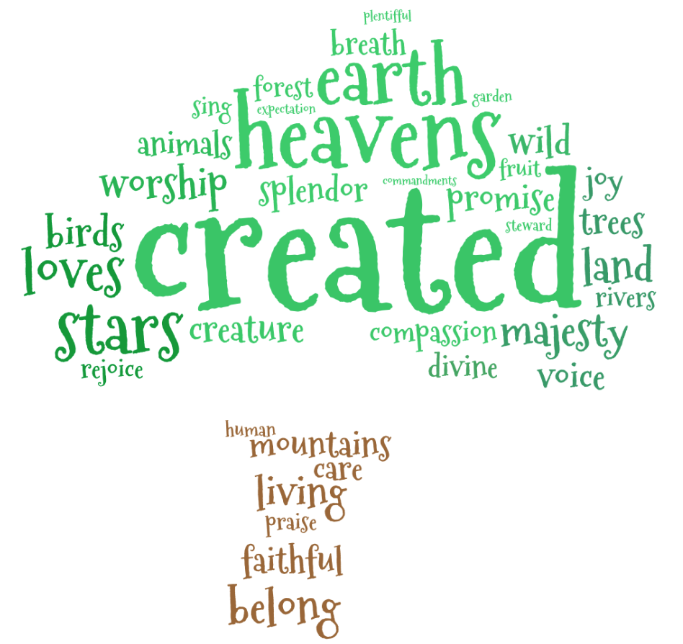

Written and adapted by Despina Francois, through the inspiration of scripture and Ruth Valerio’s book, ‘Saying Yes to Life’

